Watford Museum
Victorian Flat Iron
This iron would have been used by a laundry maid.

The iron was heated on a range, which is a type
of large cooker. There would have been two irons,
one could be heated while the other iron
was being used.
The flat iron was known also known as the ‘sad’,
which means ‘solid iron’.

How is this iron different to the iron we might use today? What energy do new irons use? Do you think that the Victorian flat iron would be easy to use?

Watford Museum
Victorian Footwarmer
This footwarmer was placed between
a person’s feet or underneath their bed sheet.

The footwarmer would have been filled with
boiling water.

Today Victorian footwarmers are collector’s
items and people use them to decorate
their homes.

What might we use today that is similar to the Victorian footwarmer? What does the writing on the footwarmer tell you about where it might come from?
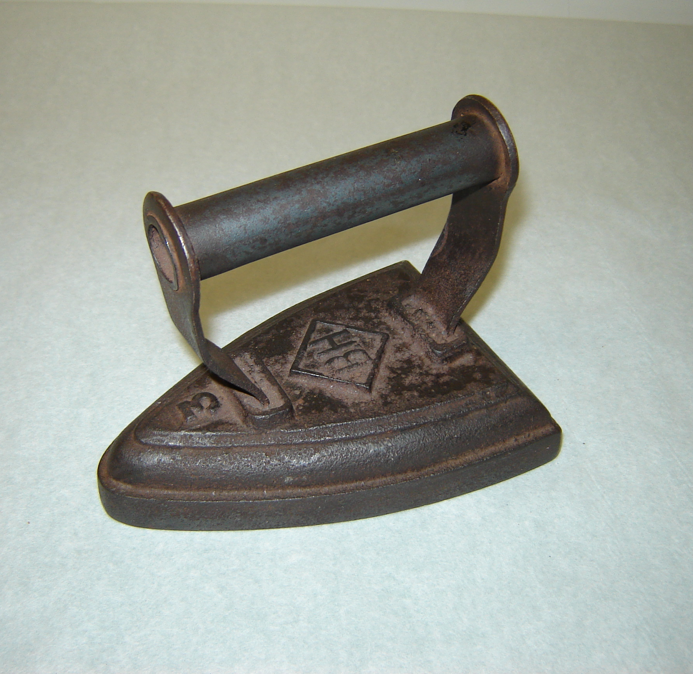

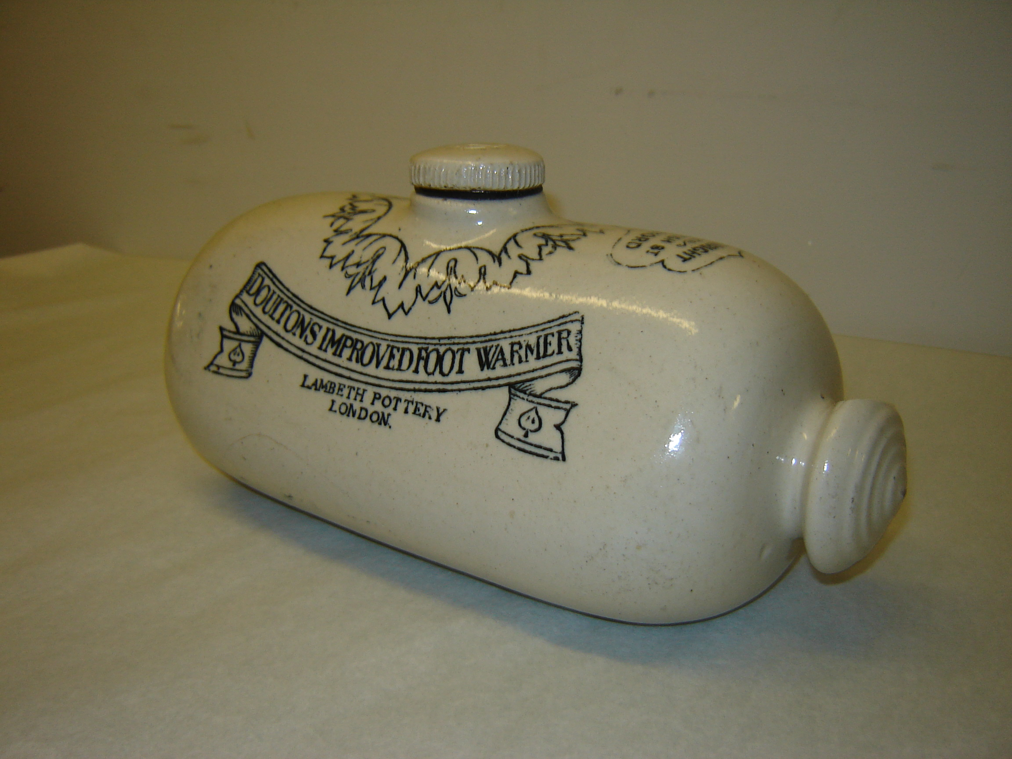

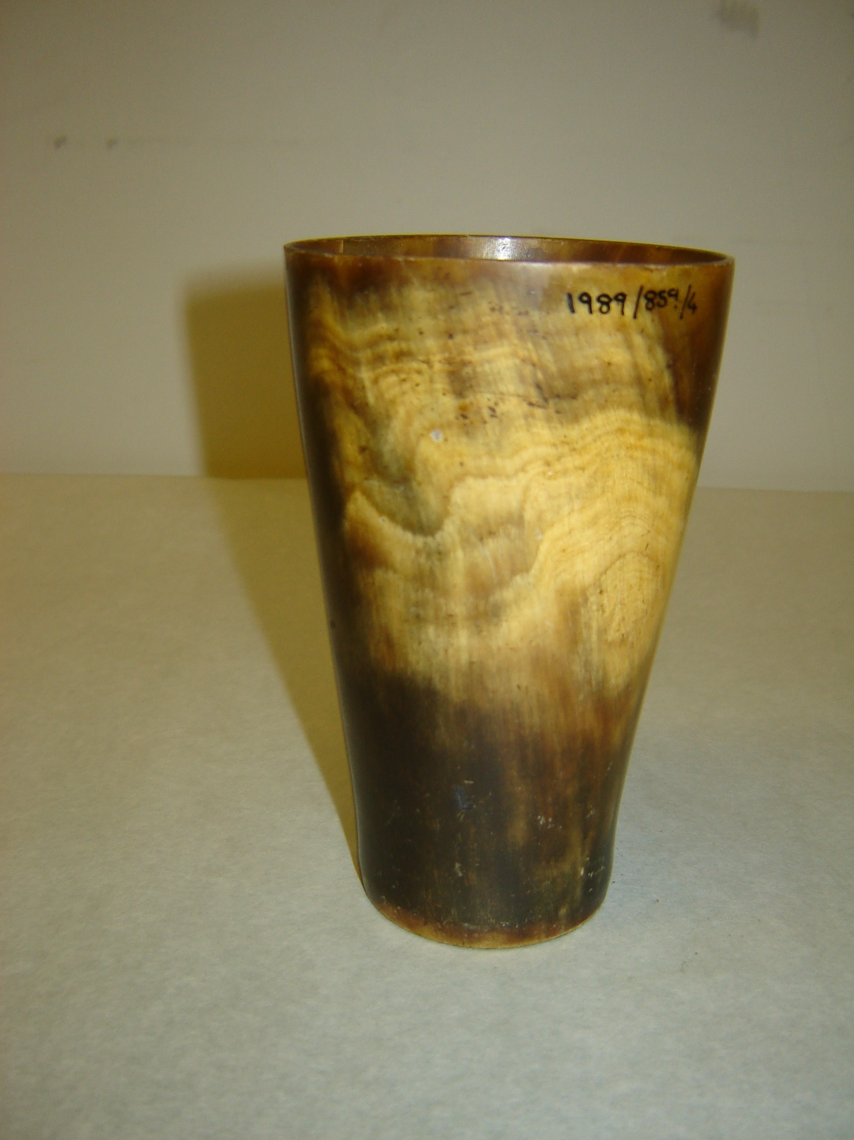
Watford Museum
Horn Cup
Cups were often made from horn as it
was a cheap and widely available material.

Unlike this cup, wealthy people would
have decorated their horn cups with silver.

What does the surface of the cup feel like? What animal might the horn have come from? What are cups made out of today?

Watford Museum
Candle Snuffers
Snuffers were used to extinguish
candle flames.

The snuffer is put over the flame
which stops oxygen getting to it,
resulting in the flame being put it out.

What do we use today to extinguish candles?

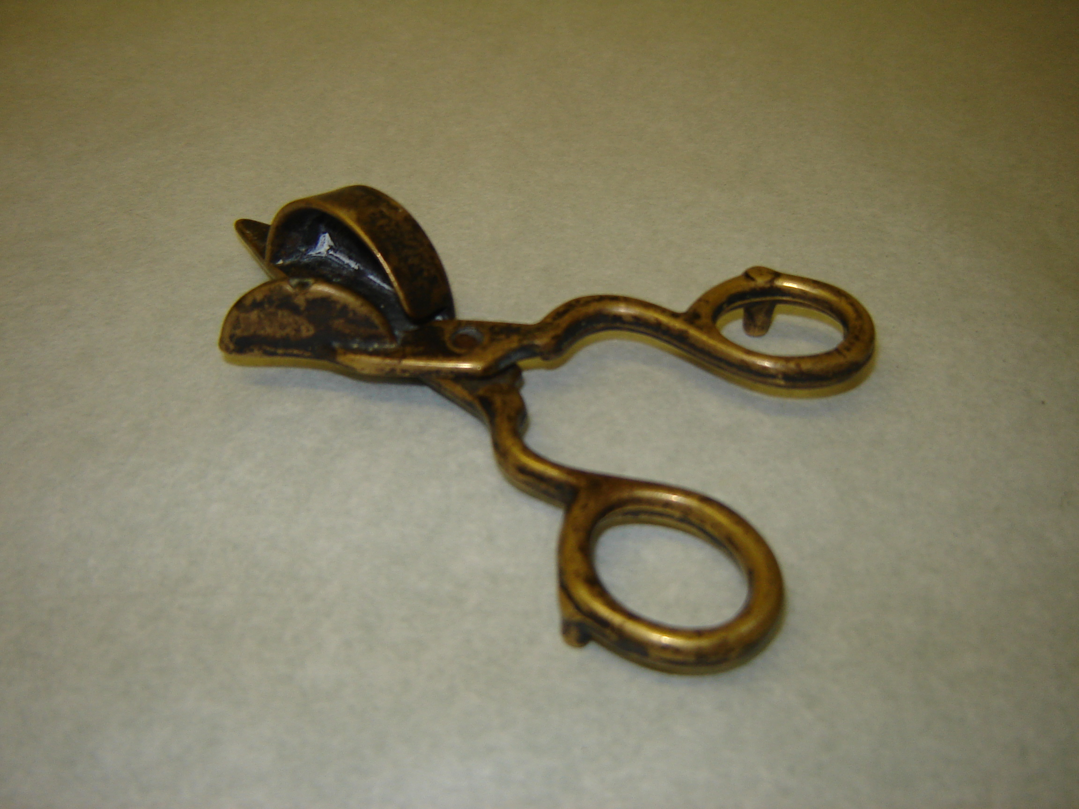

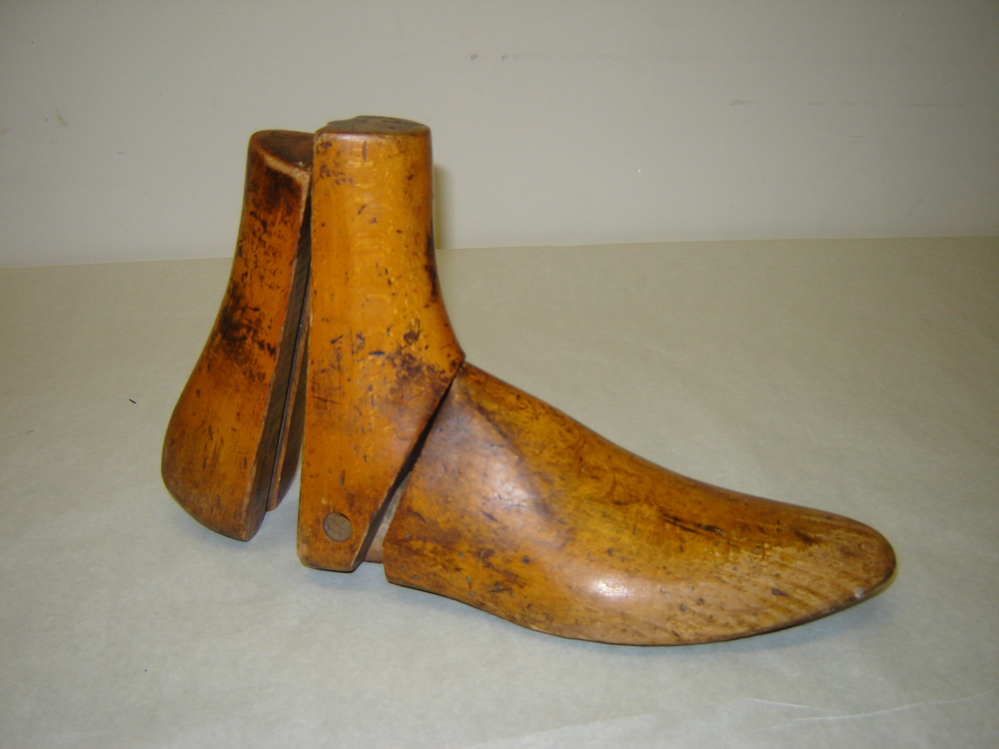
Watford Museum
Shoe Last
All footwear is made on lasts,
it creates the footwear’s size, fit
and style.
In the mid 1800s they were made
out of hard wood (maple).
Today plastic is mainly used to
make them.

What size shoe might this last make? Have a go at holding it against your own foot, or measure its size. Have a go at designing a shoe to suit the style of this last.

Watford Museum
Glove Stretcher
This wooden stretcher would have been
used to make it easier for an individual to put
their gloves on.
Women in Victorian times liked to wear
very tight gloves.
A maid would put the wooden stretcher in
each finger of the glove and squeeze the
bottom to open them out.

Do you think the glove stretcher would have been easy to use?

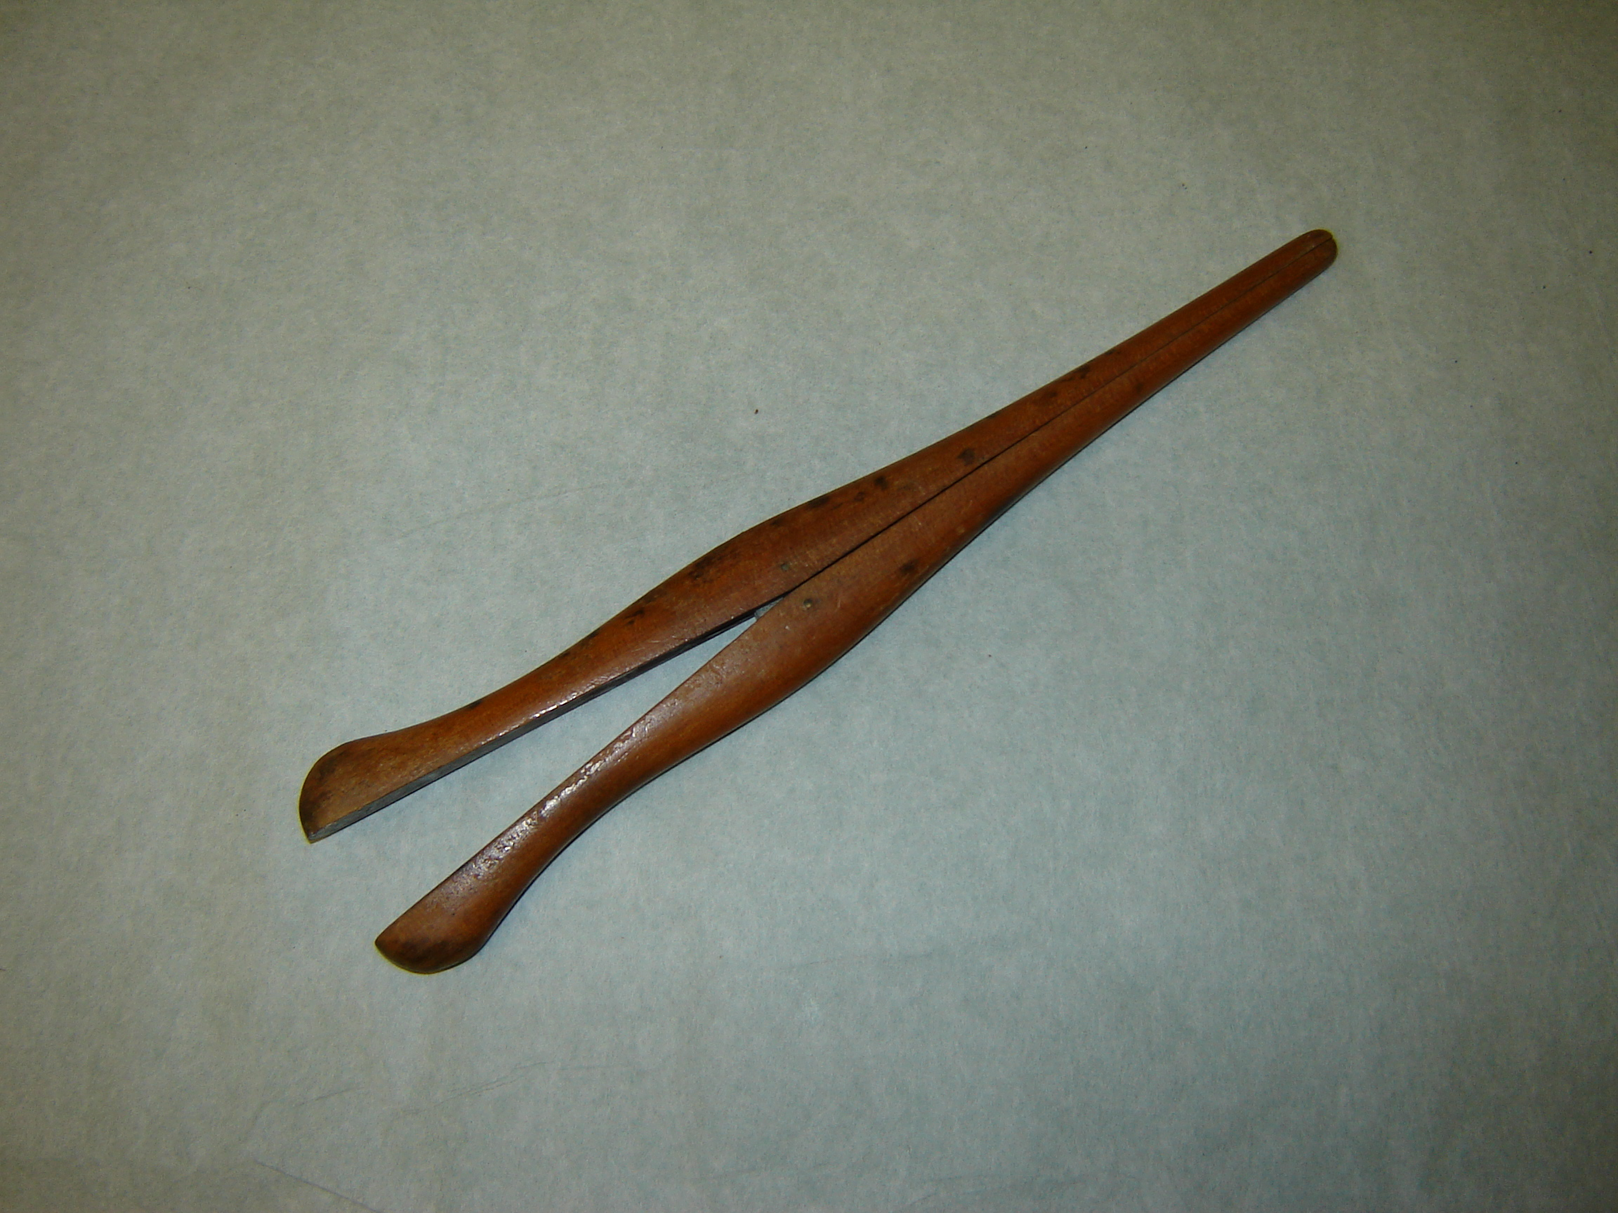

Watford Museum
Hair Tongs
Hair tongs were invented by
M. Marcel Grateau.
The tongs would have been heated on a
fire before being used to curl women’s hair.
However, this was quite damaging to hair
and reduced most women’s locks to
a wool-like texture.

What might you use to curl or straighten your hair today? How is it different from the Victorian hair tongs?
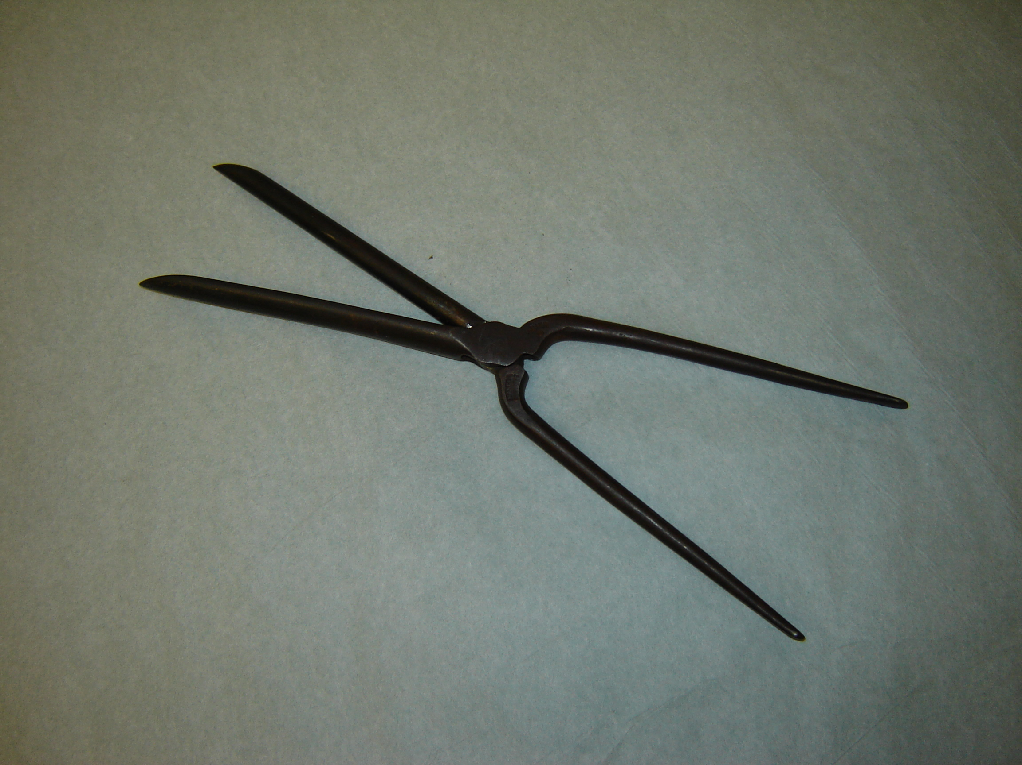

Watford Museum
Sugar Cutters
These sugar cutters were used to cut
pieces of sugar from a sugar log.
They were made from iron.

Can you find out what a sugar log might have looked like? Why do you think the cutters were made of iron?

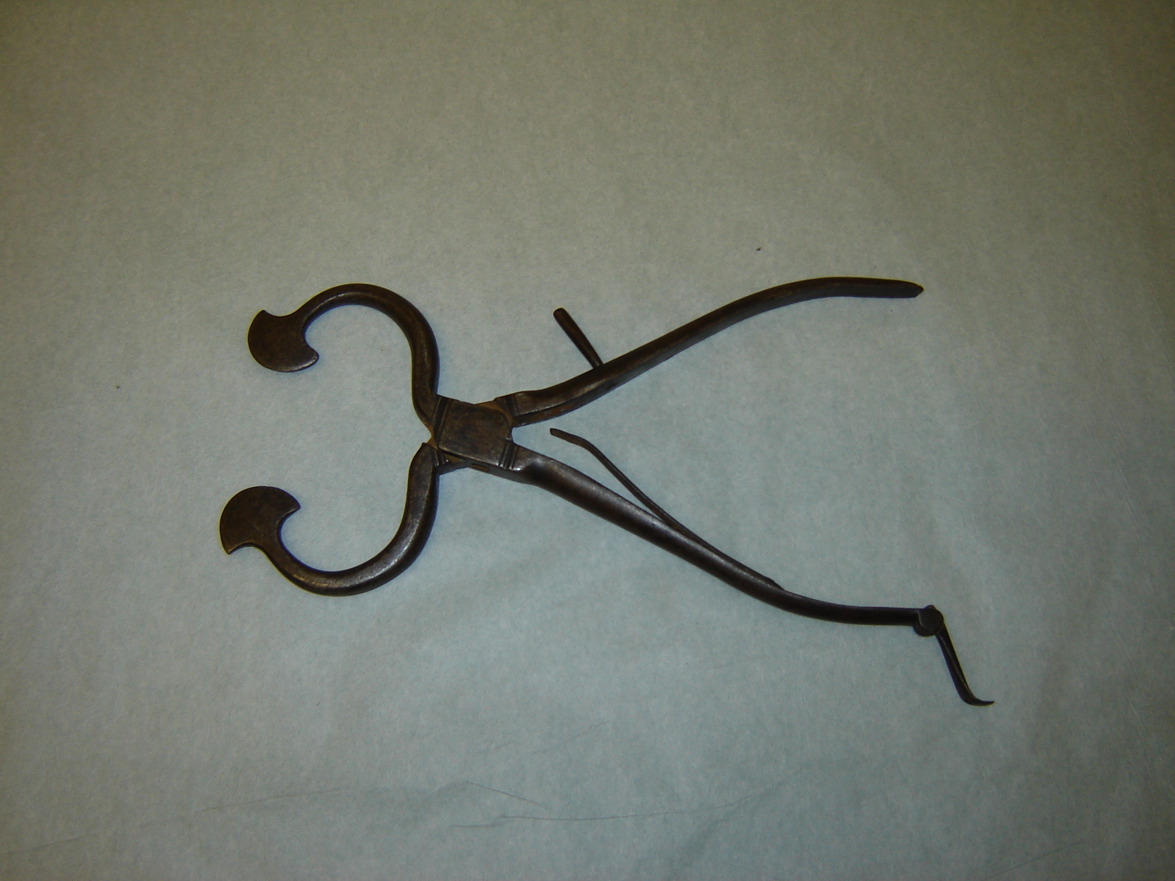

Watford Museum
Butter Pad
Butter pads were used in the 19th century
to shape butter into bricks for sale and use.
The butter maker would have held a pad in each
hand and pressed the butter to squeeze the
excess moisture out. This would shape the butter.
The inside of the pat is serrated to grip
the butter and was also used to create
patterns.
Why not have a go at shaping butter with the pads? What patterns can you create?

