Watford by road information sheet
Stagecoaches
The coaching era was one of the most important phases in England’s transport history. But its Golden Age lasted for only forty years. A journey from Watford to London took four hours by Stagecoach. Every day there where two coaches in each direction that left from a group of inns: The Essex Arms, Rose & Crown, Green Man and The George. The Rose & Crown Hotel in Watford High Street originated in the sixteenth century and was primarily a coaching inn and a staging post of the London Stagecoach Services. From the eighteenth to the nineteenth century several reports in the Times newspaper refer to it as a place congregation for criminals and disreputable types.
By 1780 the regular coaches were much faster than anything before it. The Post Office exploited this and adapted stagecoaches to carry the mail by changed team’s en-route and restricting passengers. These fast mail-coaches soon served most of the country’s main towns. The livery of these coaches was a combination of red, maroon, and black with a royal coat of arms painted on the door. This was in sharp contrast to the stagecoaches which were very colourful and bore the sign of the inn, the name of the coach, its destination, and the name of its proprietor. Many workers: barmaids, chambermaids, cooks, and waiters attended the need of the travellers; and ostlers, grooms and stable lads looked after the horses.
The dawn of the railways saw many forms of transportation that were once so popular, become obsolete. When in 1840, the Penny Post was introduced the increased volume of mail were transferred from the mail-coach companies to the railway network. The saving of time became more important to people, and the hugely faster trains were preferred to coaches. In the late nineteenth century, there was a brief revival of coaches in the Home Counties as a form of recreation. 1886 saw the last regular horse-drawn coach service, ‘The Wonder Coach’, between Watford and London. It operated between London and St. Albans, with a single fare priced at ten shillings and a return at fifteen. Six horses were drawn up Holywell Hill in St. Albans and time was given for passengers to have lunch and inspect the cathedral. This ‘Wonder Coach’ continued to carry passengers until the early twentieth century due to the internal combustion engine and motor coaches.
Cars and buses
Watford was situated in a convenient place to approach the Midlands. The high street was the main by-way and as such became congested as traffic rapidly increased. The introduction of motor cars in 1908 was of no help to this problem. The roads were also in poor condition, and in 1893 St. Albans Road had a lake 120 feet long. These problems added which the public’s difficulty in understanding traffic meant driving was hugely problematic.
Watford’s first motor bus operated from 1898 and ran from Bushey Arches to the water trough at Callowland, and there was no cover and candles were used for lighting. When the bus first started in Watford, the only means of public road travel in the town were two horse drawn buses run by the owner of the Essex Arms. The top speed of the bus was at 10 m.p.h. which was faster than the horse drawn buses that were being used. The LNW Railway began running motor buses in Watford in 1906.
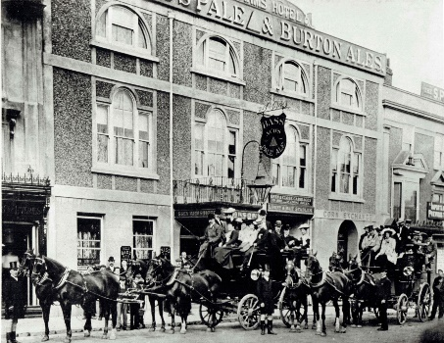
1886 Wonder Coach
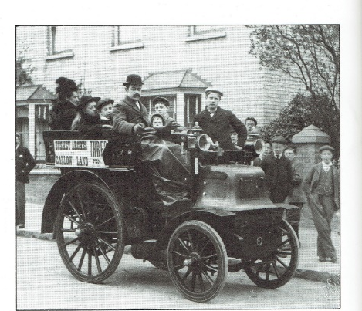
Wagonette bus service between Callowfield and Bushey Arches

