Headstone of George Edward Doney, Church Street
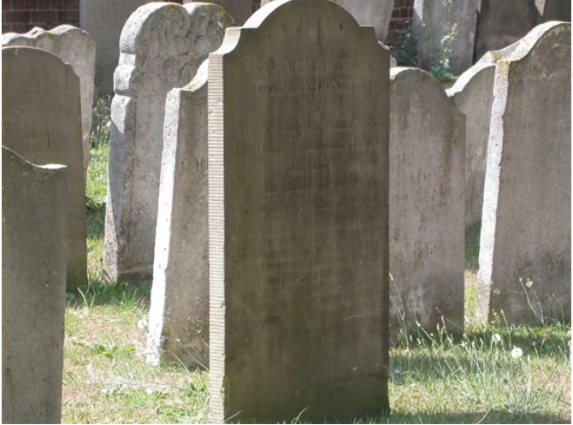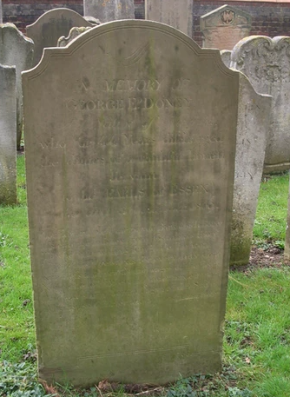
This gravestone in St Mary’s Churchyard is important not just in Watford but nationally too. George Edward Doney (c1758 – 1809) is buried by this gravestone.
He was a black servant at the Cassiobury Estate. The slave trade was abolished in 1807 but it was still legal to own slaves until 1838.
We know that George, known as Edward, was born in Gambia in West Africa. He was sold into slavery in Virginia, USA c1758. He probably lived on a cotton or tobacco plantation.
We do not know how he came to be in England. We do know he started work for the Earl of Essex aged about eight. He was christened at St Mary’s Church in 1774. He worked for the Essex family for 44 years.
The Earl of Essex supported the campaign to end slavery altogether. Although we do not know for certain who freed Doney, it is likely that the Capel family freed him and gave him paid work.
This is supported by the quality of the tombstone and the affectionate inscription on the gravestone. George Doney was obviously important to the family.
The inscription reads.
Poor Edward blest the pirate bark which bore
His captive infancy from Gambia’s shore
To where in willing servitude he won
Those blest rewards for every duty done –
Kindness and praise, the wages of the heart;
No one else to him could joy or pride impart,
And gave him, born a pagan and a slave,
A freeman’s charter and a Christian’s grave.

