Watford Museum
Ludo
The board game Ludo is based on a traditional Indian
cross and circle game called Pachisi.
Pachisi was invented in the 6th century.
To play Ludo, players roll the dice in turns and race their
four tokens from the start to the finish.
This game was popular in the Carribean and in Sweden
and was known as ‘Ludi’ and ‘Fia’.
Why not have a go at making your own Ludo board and counters?
Watford Museum
Tin Cars
Tin cars were very cheap toys.
Tin is a type of metal.
Tin toys were stronger and lasted longer than wooden toys,
which made them a popular gift.
Tin can be painted with bright colours and decorations.
What colour and patterns would you decorate your car with?

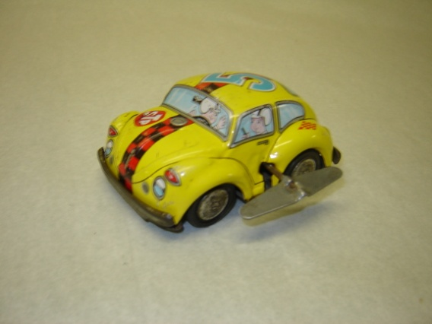

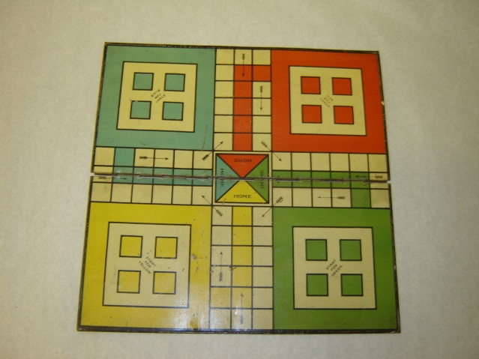

Watford Museum
Lott’s Building Bricks
In the early 1900’s, E. A. Lott created bricks that looked
like stone for children to build houses, churches, bus stations
and other buildings.
Arnold Mitchell taught Lott how to cut the bricks into
shapes that would be good for building.
Before Lotts bricks, German toy maker Richter and his Anchor
blocks were popular in Britain.
During World War One, restrictions stopped German toys
entering Britain, allowing Lott’s bricks to become popular.
Lott’s building blocks started selling in 1918, and they stopped being made in the 1960s.

What buildings can you make with Lott’s blocks? Can you make a town with your friends?

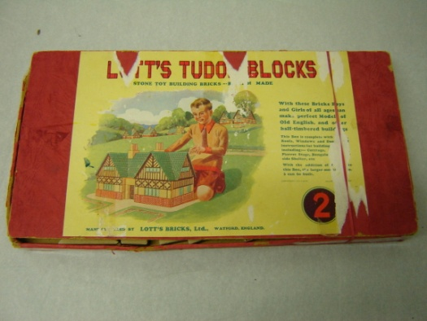

Watford Museum
Spinning Top
The spinning top is one of the world’s oldest toys. The earliest
example was found in the ancient City of Ur,
near Baghdad, Iraq in 3500BC.
Spinning tops were also used by the Greeks, Romans and Egyptians.
Spinning tops have been made from many different materials,
including clay, wood and metal.

You can make your own Spinning tops from cardboard and wooden skewers, why not have a go?

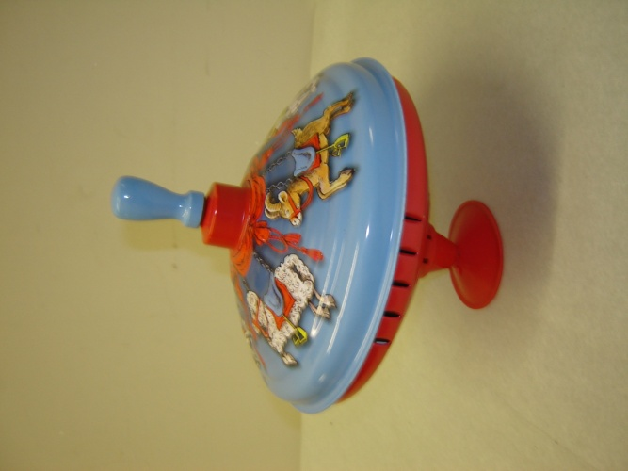

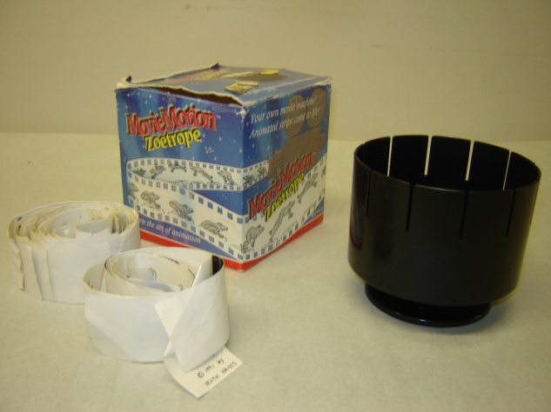
Watford Museum
Zoetrope
The first zoetrope was created in China around 180AD
by Ting Huan.
The modern zoetrope was invented in 1833 by
William George Homer.
The zoetrope is a device that produces an illusion
of a moving picture.
Have a look through the slits when the zoetrope is spun,
can you see the pictures on the strip move?

Have a go at designing your own picture strips for the Zoetrope. You could try using photography. Have a look at the work of Eadweard Muybridge for ideas.

Watford Museum
Wooden Alphabet Blocks
These were originally developed in the
17th century in England.

In 1693 philosopher John Locke stated that
‘dice and playthings, with letters on them to teach
children the alphabet by playing’, would make
learning to read a more enjoyable experience.

Many schools and nurseries still have wooden alphabet
blocks to help children learn to read.

What is the longest word you can make with the alphabet blocks?

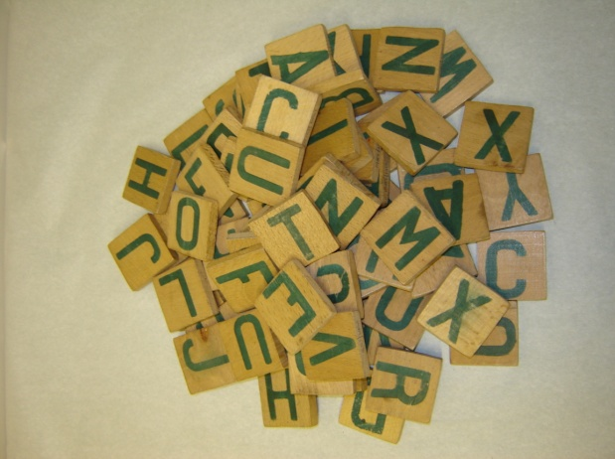

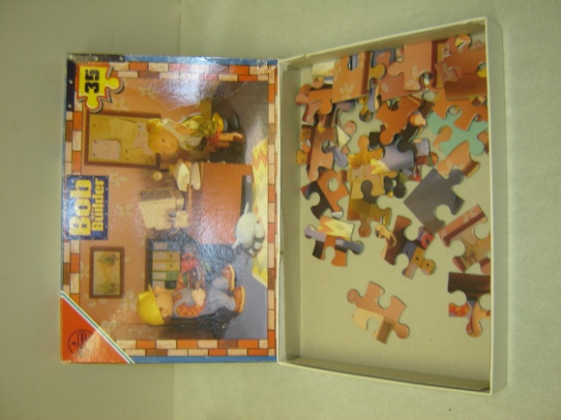
Watford Museum
Jigsaw
The jigsaw got its name from the device that was used
to cut it out, i.e a jigsaw.
John Spilsbury commercialised the jigsaw puzzle around 1760.
Spilsbury was a mapmaker. He used the jigsaw to teach
Aristocratic children geography.
He cut out the countries in the world map
and the children had to put them back in the right places.
In the 1900s, the wooden jigsaw puzzle also became popular with adults.

Why not have a go at making your own World map puzzle. Do you know where all the countries go?

Watford Museum
Cup and Ball Toy
The cup and ball toy was first made in 16th century France
and was a toy played with by King Henry III of France.
It became popular in England during Queen Elizabeth I’s
reign and was given its name ‘Cup and Ball’.
It is also known as ‘Balero’ in Latin American countries.

The cup and ball toy takes lots of concentration. How many times can you get the ball in the cup in one minute?

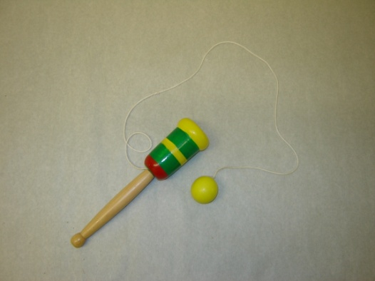

Watford Museum
Teddy Bear
The teddy bear was invented in November 1902. President Theodore ‘teddy’
Roosevelt failed to kill a bear when hunting in Mississippi. The hunting party
caught a bear for him and tied it to a tree, but Roosevelt refused to kill it
because he thought it was unsportsmanlike. Clifford Berryman drew a cartoon
of the scene and it was published in the Washington Post.
Inspired by the story, Brooklyn shopkeepers Morris and Rose Michtom made
a soft bear toy, which they named ‘Teddy’s bear’ and displayed it in their window.
America fell in love with the bear and it became the president’s mascot.
Around the same time, Margarate Steiff, a disabled German seamstress with
a soft toy factory also created a soft plush bear. She sold 3,000 in America in 1903.
People that collect teddy bears are called ‘arctophiles’.
The teddy bear celebrated its 100th birthday in 2002.

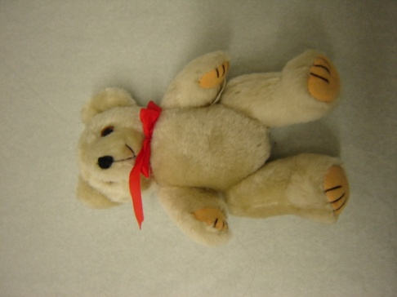

Watford Museum
Wooden Whistle
The whistle is an ancient instrument, likely to have come from
China 5000 years ago. The whistle came to Europe in the
11th century.
Whistles can be made from wood or tin. In the early 19th
Century, English whistles began to be made with the
six finger hole arrangement. Wooden whistles were very popular
with Victorian children.
Can you play a tune on the whistle?

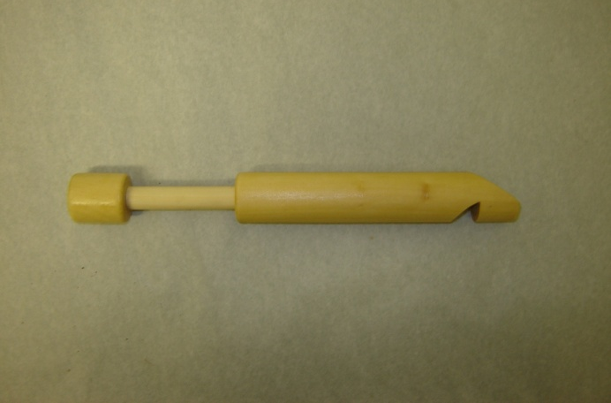

Watford Museum
Sunny Jim
Sunny Jim is the name of a character that was used to sell
Force breakfast cereal.
Force was first made in 1901 in the USA. It was one of the
first wheat-based breakfast cereal brands.
It soon became a popular cereal in Britain and people could
collect Force tokens and send money to receive a Sunny
Jim Doll. These dolls were popular in the 1960s.

Have a go at designing your own cereal.
What would you use as your mascot?
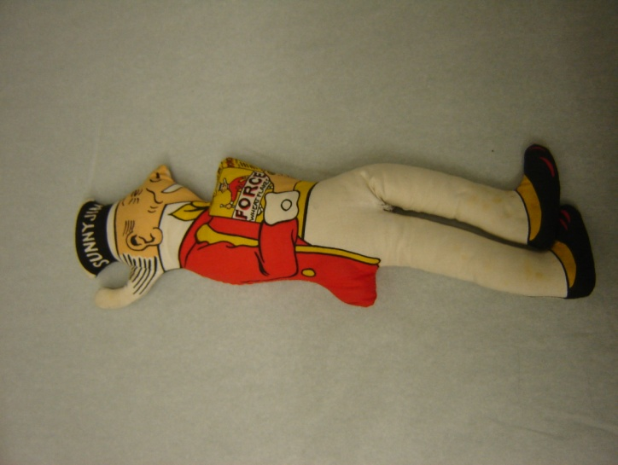

Watford Museum
Meccano

Meccano was invented in 1898 by Frank Hornby.
It was based on his creation of nuts, bolts and parts
for his two sons to build cranes, like the ones that
they would see at the Liverpool port.

Meccano can still be bought today to build all kinds
of models and mechanical devices, from cars to planes.

What will you try and make from the Meccano?

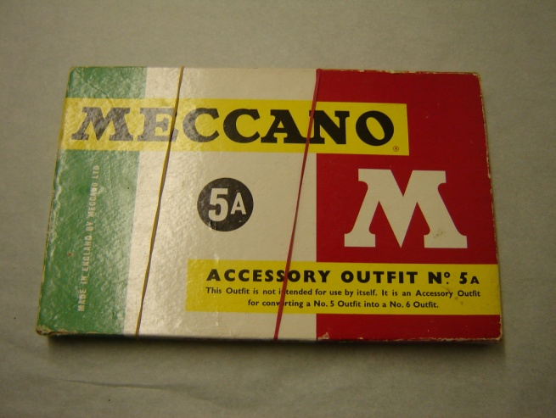

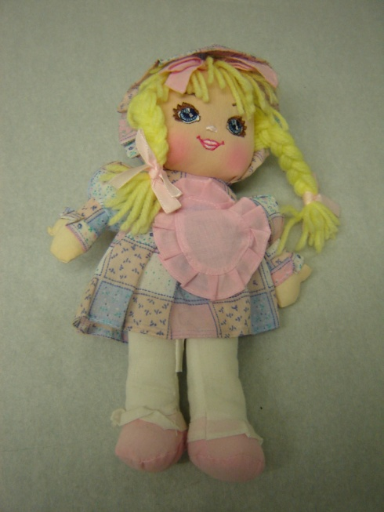
Watford Museum
Doll
Dolls have been around for many years. In 200BC, Ancient Egypt
had flat wooden dolls with hair made out of string or clay.
In the 19th century dolls were made out of porcelain, which is
a type of ceramic. The Victorians that owned the dolls thought
that porcelain looked like skin because it was thin and
slightly transparent.
The doll in the box is like a rag doll. Rag dolls were made by
mothers for their children. In the 1850s, they began to be
made commercially in England and America. A rag doll
is normally made out of cloth like linen or cotton.

Often a rag doll was a child’s first toy. What was your first toy?

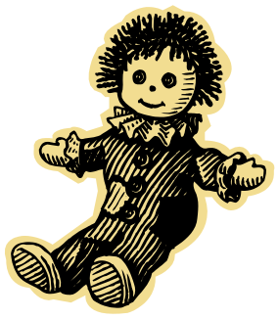
Useful Websites on Toys

Make your own Spinning Top
http://www.koolkidscrafts.com/spinning-tops.html

Zoetrope History
http://zoetrope.org/zoetrope-history
http://www.earlycinema.com/technology/zoetrope.html

Alphabet blocks
http://www.toyhalloffame.org/toys/alphabet-blocks

Childhood through time
https://www.bbc.co.uk/bitesize/topics/zc9s6g8

The Historian’s Toybox – Make Your Own Toys
http://www.arvindguptatoys.com/arvindgupta/toybox.pdf

Children’s games in the 20th century
http://www.mccord-museum.qc.ca/scripts/explore.php?Lang=1&tableid=11&tablename=theme&elementid=44__true&contentlong

