Old Watford | New Watford
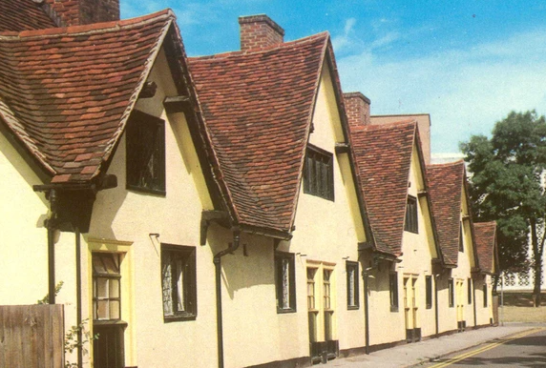 | 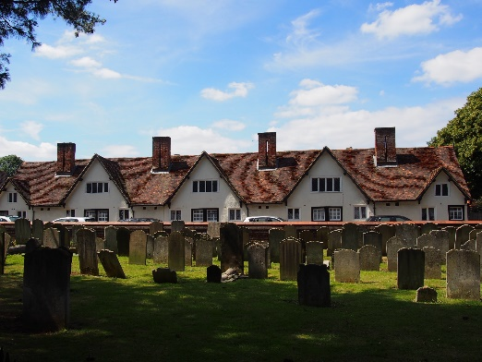
Bedford Almshouses on Church Street (near St Mary’s church)
Built in 1580 by Francis Russel Earl of Bedford for eight poor women of Chenies, Watford or Langley. Nearly knocked down in the 1930s but saved in a campaign led by the then Mayor Alderman Bickerton.

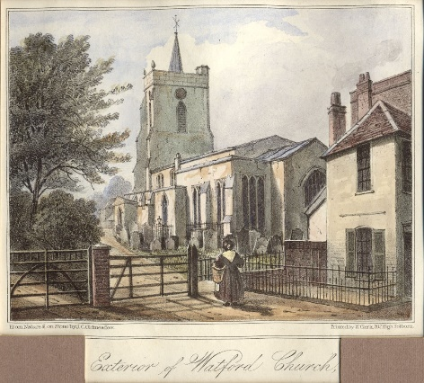1830s | 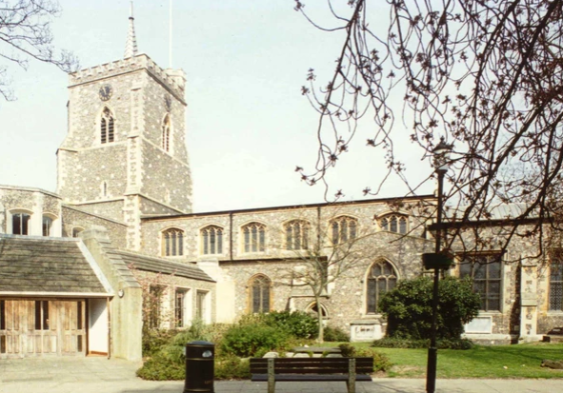
St Mary’s Church
Origins Norman, but most of the church remaining dates back to 15th century. Flint work is a Victorian addition. Inside is the Essex Chapel built in 1595 for Sir Charles Morrison.

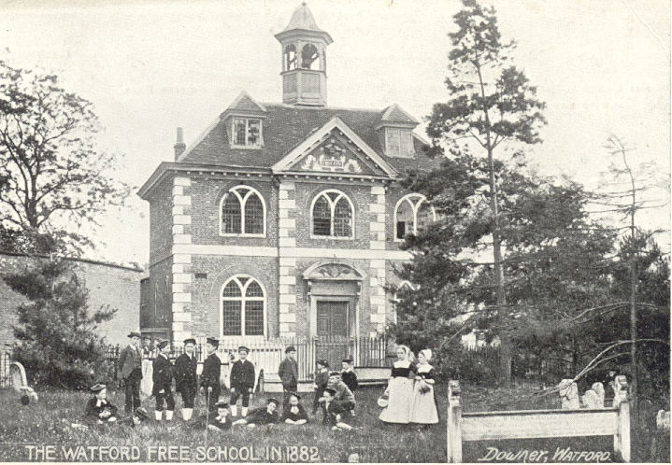 | 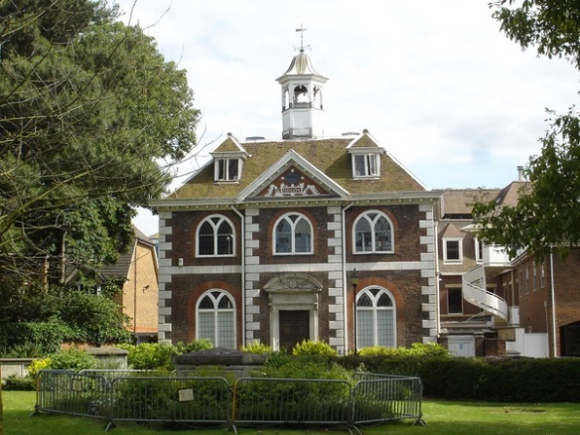
Elizabeth Fuller Free School
Founded in 1704 by Mrs Elizabeth Fuller for “the teaching of 40 poor boys and 14 poor girls of Watford in good literature and manners”. It became Boys and Girls Grammar Schools. These new schools are housed in different buildings. The free school building remains today
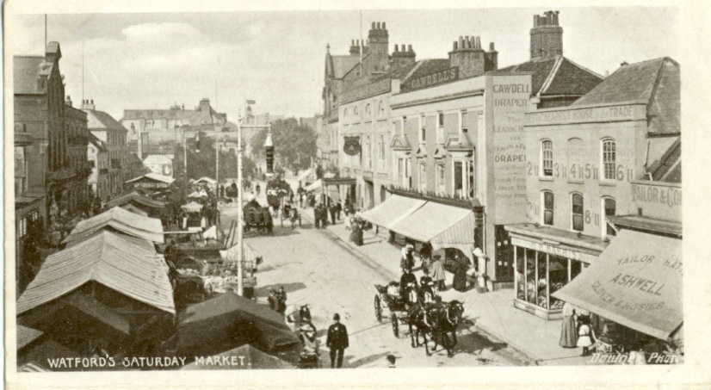 | 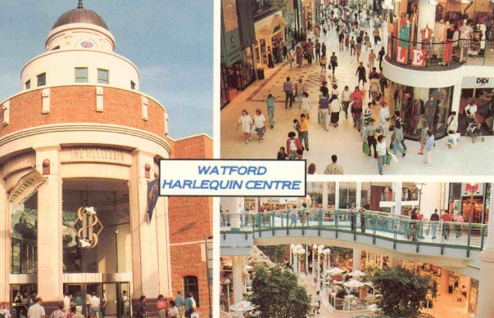
Watford shopping
There has been a market in Watford since the twelfth century .The old picture is from Victorian times. We can now shop in Atria shopping centre in 2021
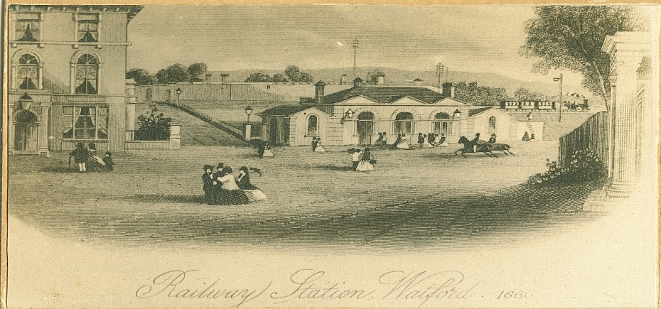 | 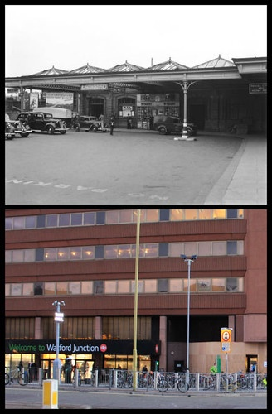
Watford Junction
The old picture is Watford junction in 1860, the new picture is Watford junction today

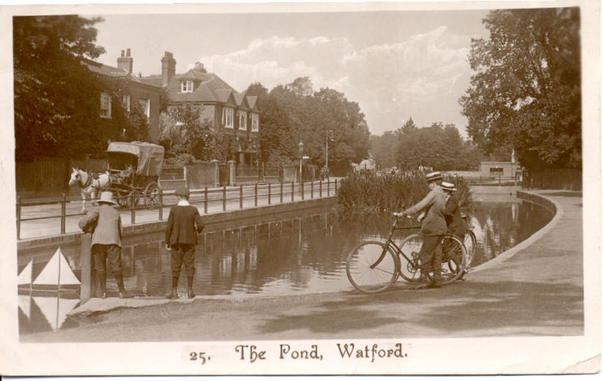 | 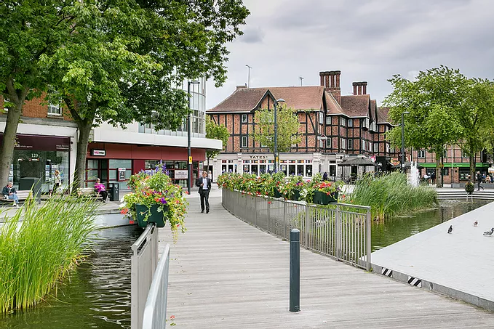
The Pond in Watford – This was a natural feature in Watford. In Victorian times people used to give their horses and livestock water here on market days. The south end sloped to provide access. Today it is a lovely place to walk.

